**Pig and Cow Facial classification**

**Deliveries**

1. ML models for identifying ear and eye poses of Cows and ear poses of pigs. (Each in two separate files)

classes

Cow => ears up, ears hanging down, eyes closed, eyes open, eyes closed

Pig => Ears forward, Ears backward, Ears asymmetrical, Ears upward, Ears sideward.

1. Python Test code.

There are two separate test codes for cow and pig. You need to run these python test code with the image name you need to test.

**Eg: python test.py –n cow.jpg**

**Requirements to run the code**

To run the models. Need to install python and python opencv library.Test codes are run in terminal. If you have anaconda or some python IDE you can comment the “argparse” section and uncommenting “image_name” section insert the name of the image there. And then run.

Sample Test results.

Following are some test results of images of cows and pigs. Test images are in the relevant folders.

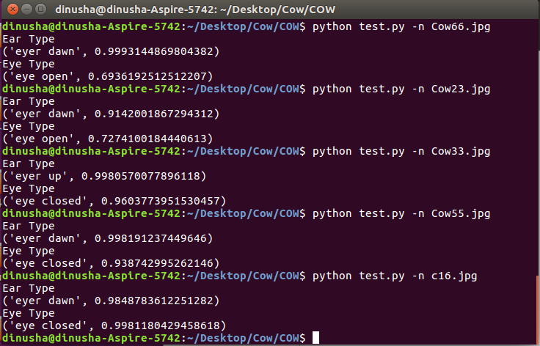**Cow**

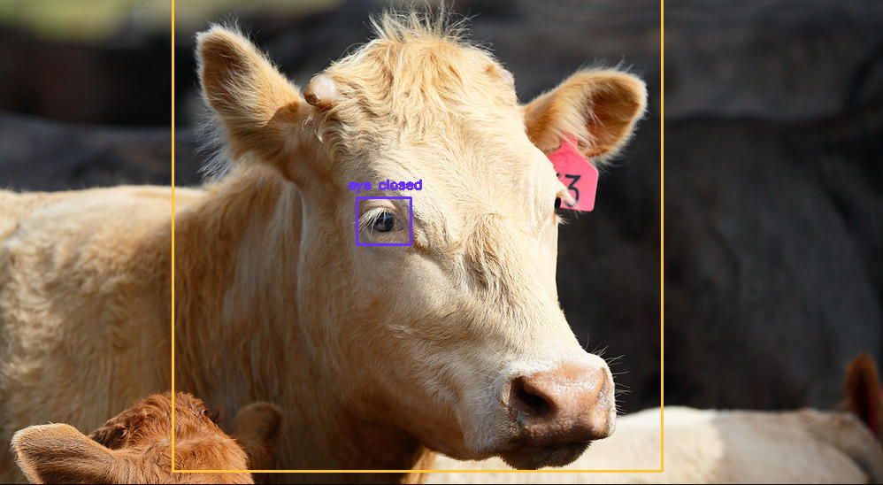

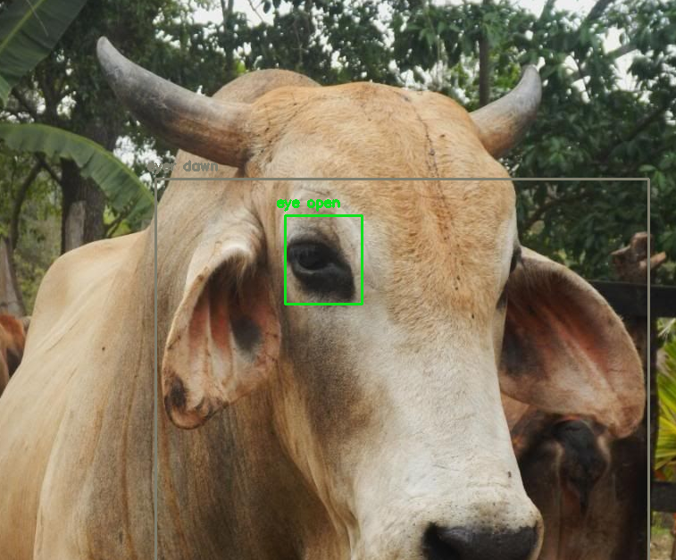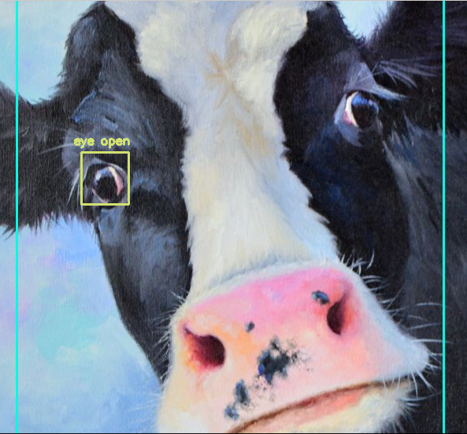

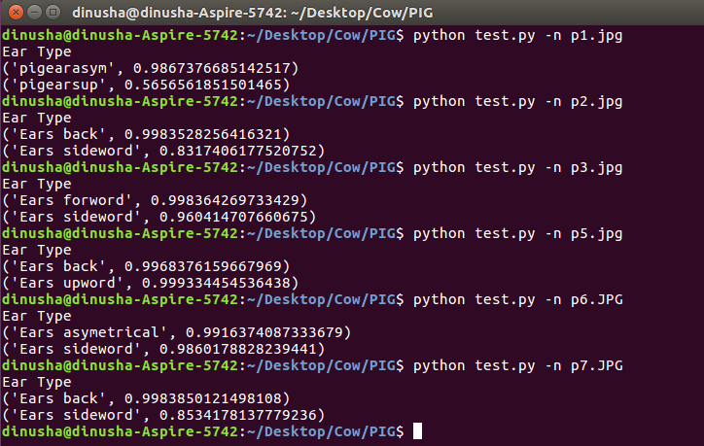**Pig**

